**Assignment -1**

Python Programming

|  |  |
| --- | --- |
| Assignment Date | 12 September 2022 |
| Student Name | M.Sneha |
| Student Roll Number | 912419104030 |
| Maximum Marks | 2 Marks |

**Question-1:**

 Split this string

s = "Hi there Sam!"

|  |
| --- |
| **Solution:** |
|  | s = "Hi there Sam!"  s.split() |
|  |  |
|  |  |
|  |  |
|  |  |
|  |  |
|  |  |
|  |  |
|  |  |

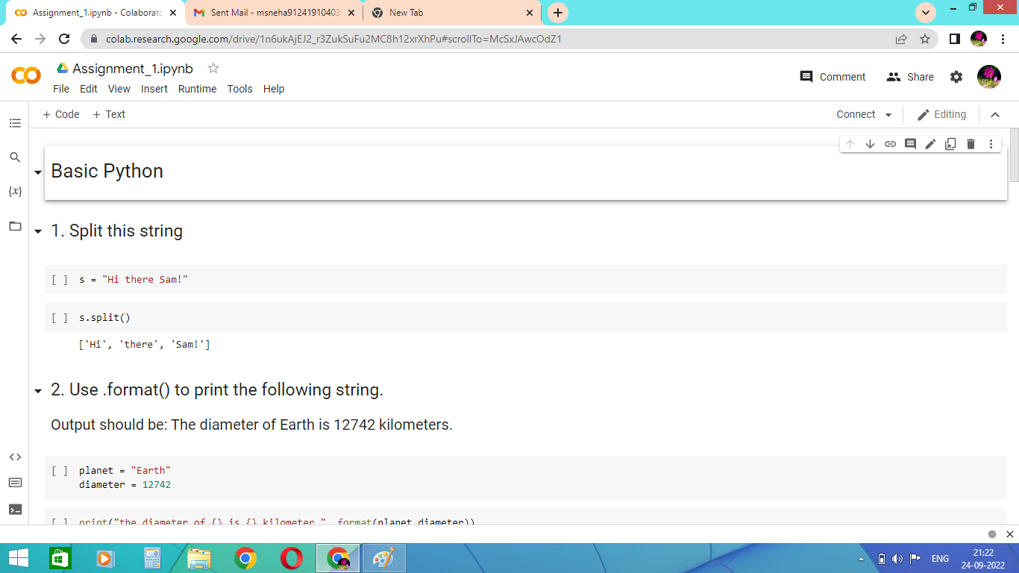

**Question-2:**

## Use .format() to print the following string.

### Output should be: The diameter of Earth is 12742 kilometers.

|  |
| --- |
| **Solution:** |
|  | planet = "Earth"  diameter = 12742  print("The diameter of {} is {} kilometers.".format(planet,diameter)) |

|  |  |
| --- | --- |
|  |  |
|  |  |
|  |  |
|  |  |
|  |  |
|  |  |
|  |  |

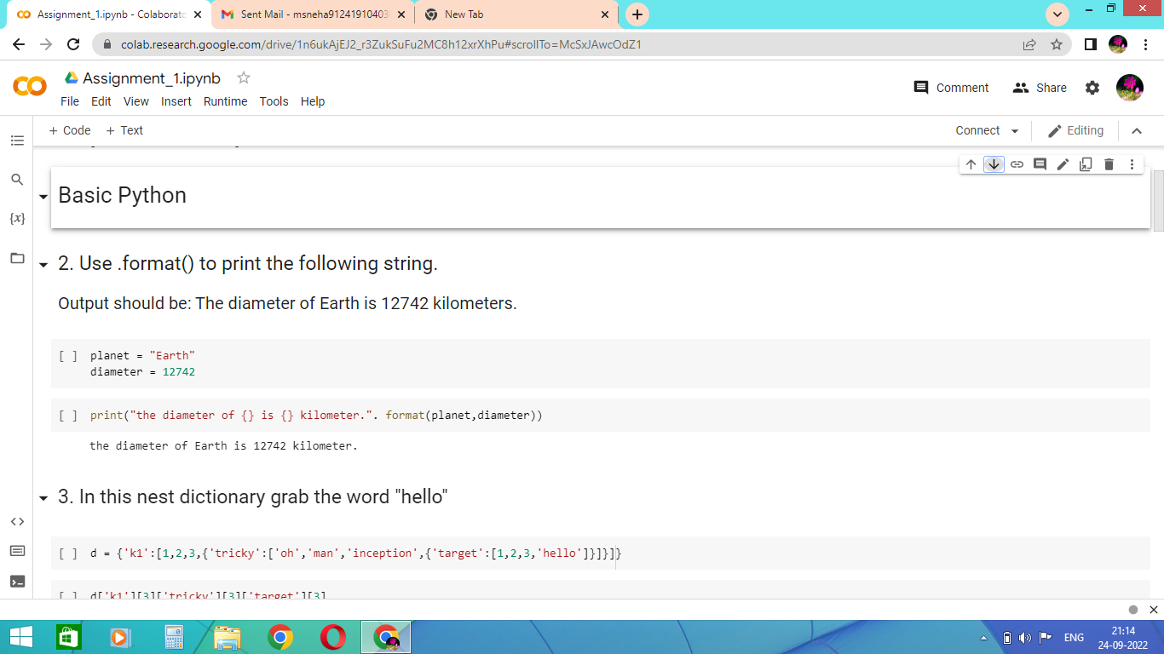

**Question-3:**

## In this nest dictionary grab the word "hello"

d = {'k1':[1,2,3,{'tricky':['oh','man','inception',{'target':[1,2,3,'hello']}]}]}

|  |
| --- |
| **Solution:** |
|  | d = {'k1':[1,2,3,{'tricky':['oh','man','inception',{'target':[1,2,3,'hello']}]}]}  d['k1'][3]['tricky'][3]['target'][3]  planet = "Earth"  diameter = 12742  print("The diameter of {} is {} kilometers.".format(planet,diameter)) |

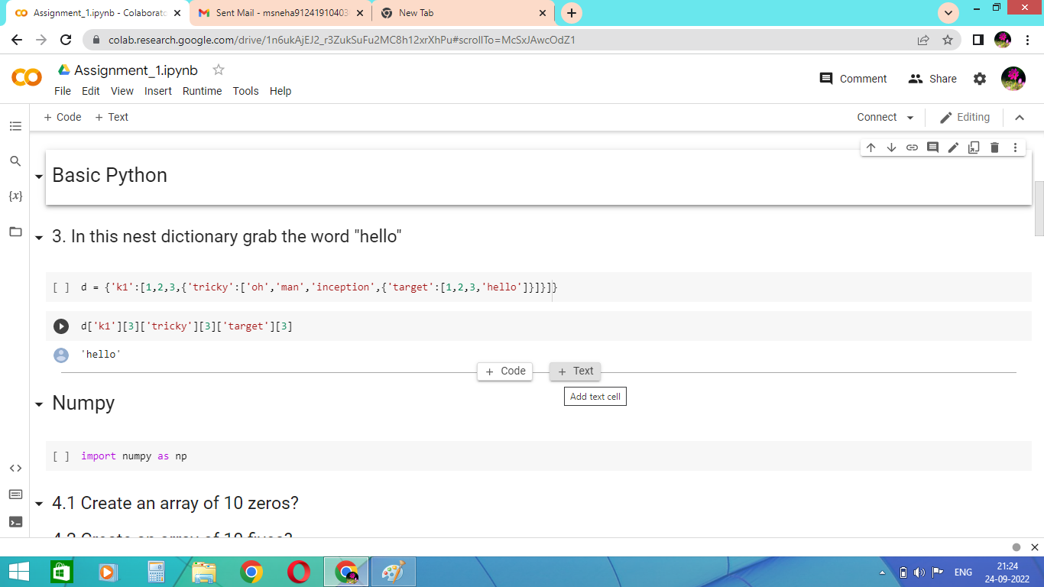

**Question-4:**

## 4.1 Create an array of 10 zeros?

## 4.2 Create an array of 10 fives?

|  |
| --- |
| **Solution:**  import numpy as np  np.zeros(10)  np.ones(10)*5  4.jpg |
|  |

**Question-5:**

## Create an array of all the even integers from 20 to 35

|  |
| --- |
|  |
|  |  |

Solution:

np.arange(20,35,2)

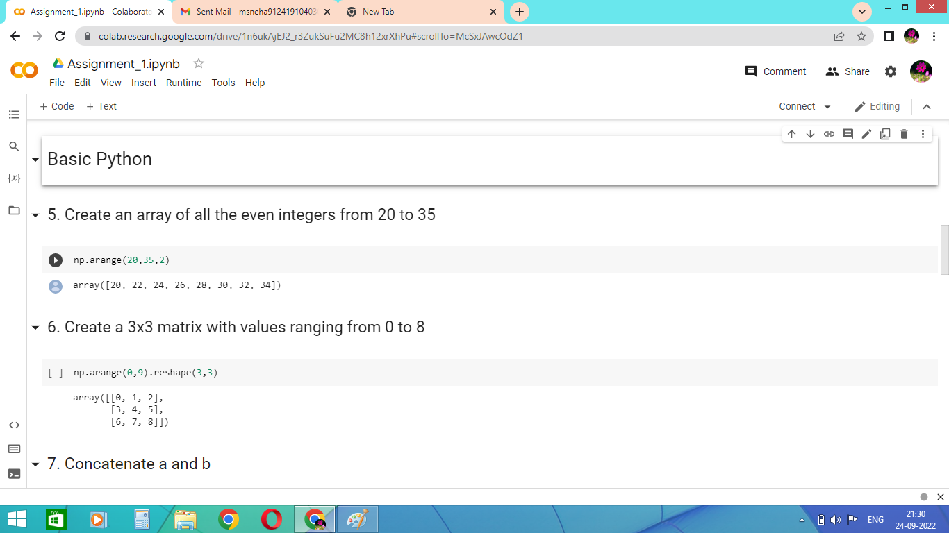

**Question-6:**

## Create an array of all the even integers from 20 to 35

Solution:

np.arange(0,9).reshape(3,3)



**Question-7:**

## Concatenate a and b

## a = np.array([1, 2, 3]), b = np.array([4, 5, 6])

## 

Solution:

a=np.array([1,2,3])

b=np.array([4,5,6])

np.concatenate((a,b))

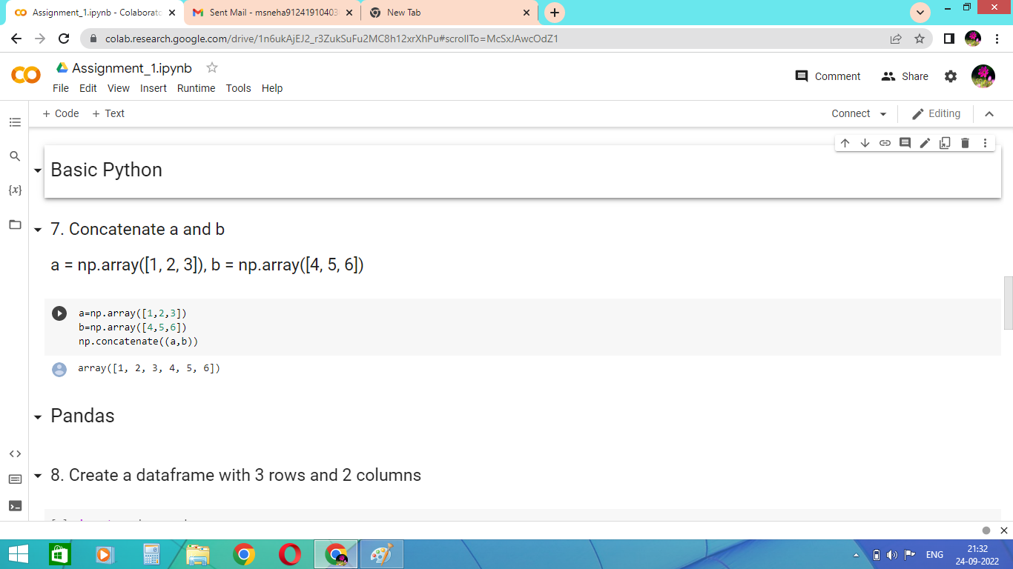

**Question-8:**

## Create a dataframe with 3 rows and 2 columns

Solution:

import pandas as pd

d={"id":[4001,4002,4003],"name":["valar","ammu","sangeetha"]}

df=pd.DataFrame(d)

df

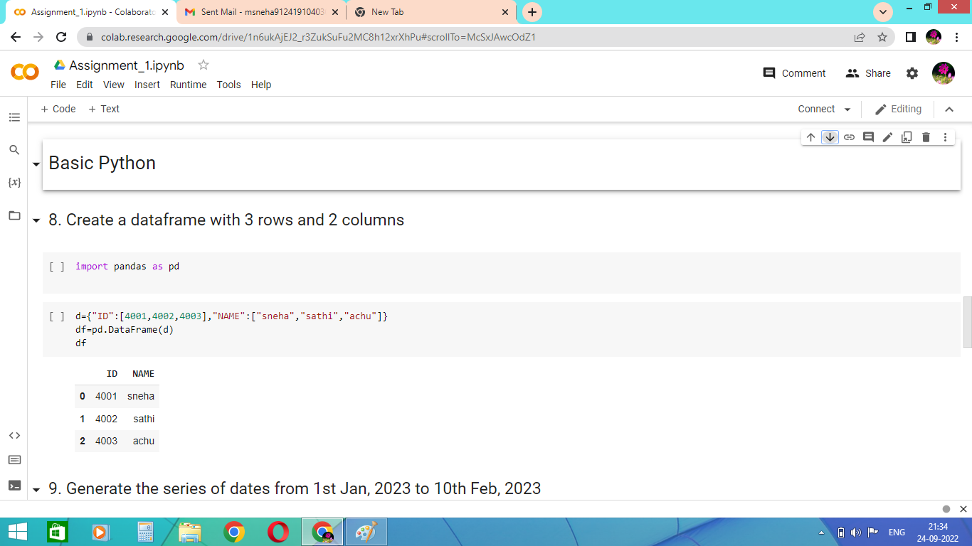

**Question-9:**

## Generate the series of dates from 1st Jan, 2023 to 10th Feb, 2023

Solution:

import pandas as pd

date_series=pd.Series(pd.date_range("2023-01-01","2023-02-10"))

print(date_series)

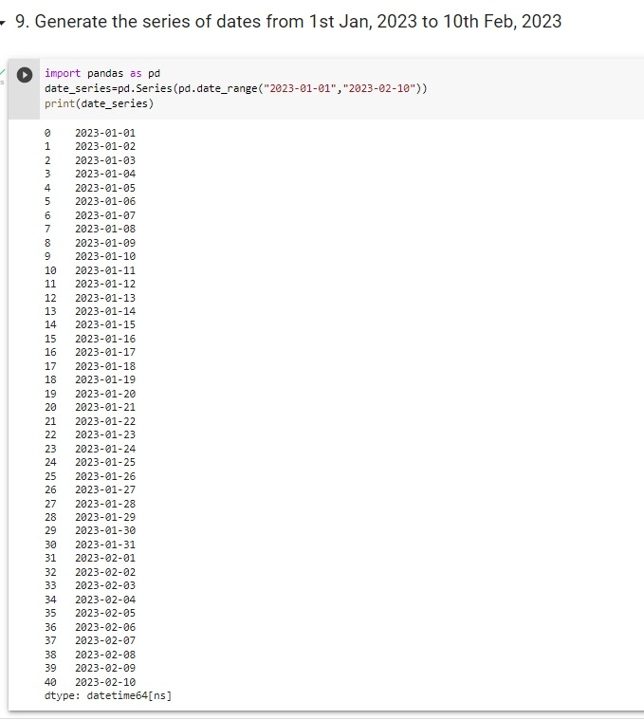

**Question-10:**

## Create 2D list to DataFrame

lists = [[1, 'aaa', 22], [2, 'bbb', 25], [3, 'ccc', 24]]

Solution:

lists = [[1, 'aaa', 22], [2, 'bbb', 25], [3, 'ccc', 24]]

list1=zip(lists)

df=pd.DataFrame(list1)

df

